**Artificial Intelligence Lab**

**LAB 10 – Implementation of block world problems**

**Aditya Kumar**

**RA1911030010100**

**O2 Section**

**Date – 1/4/22**

**Problem Statement :**

Implementation of block world problem.

**Algorithm :**

1. Create initial state and final state
2. Perform algorithm to reach to the goal state using actions
3. Print actions in the output

**Code:**

class PREDICATE:

def __str__(self):

pass

def __repr__(self):

pass

def __eq__(self, other) :

pass

def __hash__(self):

pass

def get_action(self, world_state):

pass

#OPERATIONS - Stack, Unstack, Pickup, Putdown

class Operation:

def __str__(self):

pass

def __repr__(self):

pass

def __eq__(self, other) :

pass

def precondition(self):

pass

def delete(self):

pass

def add(self):

pass

class ON(PREDICATE):

def __init__(self, X, Y):

self.X = X

self.Y = Y

def __str__(self):

return "ON({X},{Y})".format(X=self.X,Y=self.Y)

def __repr__(self):

return self.__str__()

def __eq__(self, other) :

return self.__dict__ == other.__dict__ and self.__class__ == other.__class__

def __hash__(self):

return hash(str(self))

def get_action(self, world_state):

return StackOp(self.X,self.Y)

class ONTABLE(PREDICATE):

def __init__(self, X):

self.X = X

def __str__(self):

return "ONTABLE({X})".format(X=self.X)

def __repr__(self):

return self.__str__()

def __eq__(self, other) :

return self.__dict__ == other.__dict__ and self.__class__ == other.__class__

def __hash__(self):

return hash(str(self))

def get_action(self, world_state):

return PutdownOp(self.X)

class CLEAR(PREDICATE):

def __init__(self, X):

self.X = X

def __str__(self):

return "CLEAR({X})".format(X=self.X)

self.X = X

def __repr__(self):

return self.__str__()

def __eq__(self, other) :

return self.__dict__ == other.__dict__ and self.__class__ == other.__class__

def __hash__(self):

return hash(str(self))

def get_action(self, world_state):

for predicate in world_state:

#If Block is on another block, unstack

if isinstance(predicate,ON) and predicate.Y==self.X:

return UnstackOp(predicate.X, predicate.Y)

return None

class HOLDING(PREDICATE):

def __init__(self, X):

self.X = X

def __str__(self):

return "HOLDING({X})".format(X=self.X)

def __repr__(self):

return self.__str__()

def __eq__(self, other) :

return self.__dict__ == other.__dict__ and self.__class__ == other.__class__

def __hash__(self):

return hash(str(self))

def get_action(self, world_state):

X = self.X

#If block is on table, pick up

if ONTABLE(X) in world_state:

return PickupOp(X)

#If block is on another block, unstack

else:

for predicate in world_state:

if isinstance(predicate,ON) and predicate.X==X:

return UnstackOp(X,predicate.Y)

class ARMEMPTY(PREDICATE):

def __init__(self):

pass

def __str__(self):

return "ARMEMPTY"

def __repr__(self):

return self.__str__()

def __eq__(self, other) :

return self.__dict__ == other.__dict__ and self.__class__ == other.__class__

def __hash__(self):

return hash(str(self))

def get_action(self, world_state=[]):

for predicate in world_state:

if isinstance(predicate,HOLDING):

return PutdownOp(predicate.X)

return None

class StackOp(Operation):

def __init__(self, X, Y):

self.X = X

self.Y = Y

def __str__(self):

return "STACK({X},{Y})".format(X=self.X,Y=self.Y)

def __repr__(self):

return self.__str__()

def __eq__(self, other) :

return self.__dict__ == other.__dict__ and self.__class__ == other.__class__

def precondition(self):

return [ CLEAR(self.Y) , HOLDING(self.X) ]

def delete(self):

return [ CLEAR(self.Y) , HOLDING(self.X) ]

def add(self):

return [ ARMEMPTY() , ON(self.X,self.Y) ]

class UnstackOp(Operation):

def __init__(self, X, Y):

self.X = X

self.Y = Y

def __str__(self):

return "UNSTACK({X},{Y})".format(X=self.X,Y=self.Y)

def __repr__(self):

return self.__str__()

def __eq__(self, other) :

return self.__dict__ == other.__dict__ and self.__class__ == other.__class__

def precondition(self):

return [ ARMEMPTY() , ON(self.X,self.Y) , CLEAR(self.X) ]

def delete(self):

return [ ARMEMPTY() , ON(self.X,self.Y) ]

def add(self):

return [ CLEAR(self.Y) , HOLDING(self.X) ]

class PickupOp(Operation):

def __init__(self, X):

self.X = X

def __str__(self):

return "PICKUP({X})".format(X=self.X)

def __repr__(self):

return self.__str__()

def __eq__(self, other) :

return self.__dict__ == other.__dict__ and self.__class__ == other.__class__

def precondition(self):

return [ CLEAR(self.X) , ONTABLE(self.X) , ARMEMPTY() ]

def delete(self):

return [ ARMEMPTY() , ONTABLE(self.X) ]

def add(self):

return [ HOLDING(self.X) ]

class PutdownOp(Operation):

def __init__(self, X):

self.X = X

def __str__(self):

return "PUTDOWN({X})".format(X=self.X)

def __repr__(self):

return self.__str__()

def __eq__(self, other) :

return self.__dict__ == other.__dict__ and self.__class__ == other.__class__

def precondition(self):

return [ HOLDING(self.X) ]

def delete(self):

return [ HOLDING(self.X) ]

def add(self):

return [ ARMEMPTY() , ONTABLE(self.X) ]

def isPredicate(obj):

predicates = [ON, ONTABLE, CLEAR, HOLDING, ARMEMPTY]

for predicate in predicates:

if isinstance(obj,predicate):

return True

return False

def isOperation(obj):

operations = [StackOp, UnstackOp, PickupOp, PutdownOp]

for operation in operations:

if isinstance(obj,operation):

return True

return False

def arm_status(world_state):

for predicate in world_state:

if isinstance(predicate, HOLDING):

return predicate

return ARMEMPTY()

class GoalStackPlanner:

def __init__(self, initial_state, goal_state):

self.initial_state = initial_state

self.goal_state = goal_state

def get_steps(self):

#Store Steps

steps = []

#Program Stack

stack = []

#World State/Knowledge Base

world_state = self.initial_state.copy()

#Initially push the goal_state as compound goal onto the stack

stack.append(self.goal_state.copy())

#Repeat until the stack is empty

while len(stack)!=0:

#Get the top of the stack

stack_top = stack[-1]

#If Stack Top is Compound Goal, push its unsatisfied goals onto stack

if type(stack_top) is list:

compound_goal = stack.pop()

for goal in compound_goal:

if goal not in world_state:

stack.append(goal)

#If Stack Top is an action

elif isOperation(stack_top):

#Peek the operation

operation = stack[-1]

all_preconditions_satisfied = True

#Check if any precondition is unsatisfied and push it onto program stack

for predicate in operation.delete():

if predicate not in world_state:

all_preconditions_satisfied = False

stack.append(predicate)

#If all preconditions are satisfied, pop operation from stack and execute it

if all_preconditions_satisfied:

stack.pop()

steps.append(operation)

for predicate in operation.delete():

world_state.remove(predicate)

for predicate in operation.add():

world_state.append(predicate)

#If Stack Top is a single satisfied goal

elif stack_top in world_state:

stack.pop()

#If Stack Top is a single unsatisfied goal

else:

unsatisfied_goal = stack.pop()

#Replace Unsatisfied Goal with an action that can complete it

action = unsatisfied_goal.get_action(world_state)

stack.append(action)

#Push Precondition on the stack

for predicate in action.precondition():

if predicate not in world_state:

stack.append(predicate)

return steps

if __name__ == '__main__':

initial_state = [

ON('B','A'),

ON('C','B'),

ONTABLE('A'),ONTABLE('D'),

CLEAR('C'),CLEAR('D'),

ARMEMPTY()

]

goal_state = [

ON('B','D'),ON('C','A'),

ONTABLE('D'),ONTABLE('A'),

CLEAR('B'),CLEAR('C'),

ARMEMPTY()

]

goal_stack = GoalStackPlanner(initial_state=initial_state, goal_state=goal_state)

steps = goal_stack.get_steps()

print(steps)

OUTPUT:

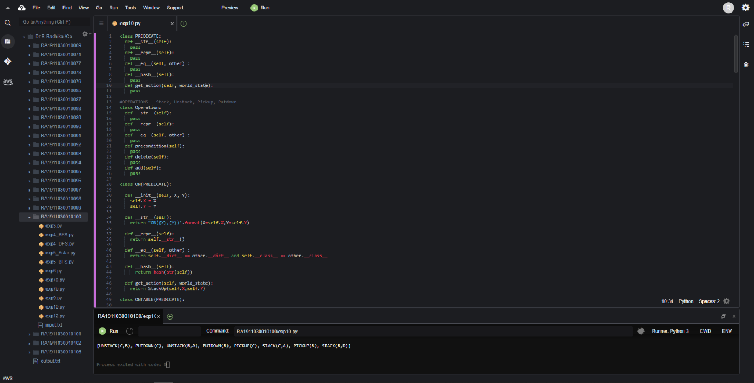

RESULT :

Hence we implemented block world problem and executed it.